# MoviePlug Ticketing System

Software Requirements Specification

Version 2

Oct 5, 2023

Group 5

Ruben Guillen

Justin Pudiquet

Rosa Lisa Silipino

Prepared for

CS 250- Introduction to Software Systems

Instructor: Gus Hanna, Ph.D.

Fall 2023

# **Revision History**

| **Date** | **Description** | **Author** | **Comments** |
| --- | --- | --- | --- |
| Sept-21 | Version 1 | Group 5 | Sect. 1.1 - 3.5, excluding 3.4 |
| Oct-5 | Version 2 | Group 5 | Added Design Portion |
|  |  |  |  |
|  |  |  |  |

# **Document Approval**

The following Software Requirements Specification has been accepted and approved by the following:

| **Signature** | **Printed Name** | **Title** | **Date** |
| --- | --- | --- | --- |
|  | Group 5 | Software Eng. | Sept 21, 2023 |
|  | Dr. Gus Hanna | Instructor, CS 250 |  |
|  |  |  |  |

# **Table of Contents**

**MoviePlug Ticketing System 1**

**Revision History 1**

**Document Approval 2**

**Table of Contents 3**

**1. Introduction 5**

1.1 Purpose 5

1.2 Scope 5

1.3 Definitions, Acronyms, and Abbreviations 5

1.4 References 6

1.5 Overview 6

**2. General Description 6**

2.1 Product Perspective 6

2.2 Product Functions 6

2.3 User Characteristics 6

2.4 General Constraints 7

2.5 Assumptions and Dependencies 7

**3. Specific Requirements 7**

3.1 External Interface Requirements 7

3.1.1 User Interfaces 7

3.1.2 Hardware Interfaces 7

3.1.3 Software Interfaces 7

3.1.4 Communications Interfaces 8

MoviePlug Ticketing System shall utilize the HTTP protocol for communication over the internet and for the intranet communication will be through TCP/IP protocol suite. 8

3.2 Functional Requirements 8

3.2.1 Storage of Customers’ Login Profiles 8

3.2.2 Personalized Customer Profiles 8

3.2.3 Loyalty Memberships 8

3.2.4 Movie Listings and Details 8

3.2.5 Showtimes and Theater Information 8

3.2.6 Search Functionality 9

3.2.7 Seat Selection 9

3.2.8 Payment Options 9

3.2.9 Payment Security 9

3.2.10 Pricing and Discounts 9

3.2.11 Payment Receipt 10

3.2.12 Refunds and Cancellations 10

3.2.13 Ticket Format 10

3.2.14 Ticket Generation 10

3.2.15 Ticket Printing and Delivery 10

3.2.16 Movie Reviews 10

3.2.17 Customer Support 11

3.3 Use Cases 11

3.3.1 Customer Login Process 11

3.3.2 Customer Searching For Movie 12

3.3.3 Customer’s Payment Process 13

3.4 Classes / Objects 14

3.4.1 <Class / Object #1> 14

3.5 Non-Functional Requirements 14

3.5.1 Performance 14

3.5.2 Reliability 15

3.5.3 Availability 15

3.5.4 Security 15

3.5.5 Maintainability 15

3.5.6 Portability 15

**System Description 16**

**Software Architecture Overview 16**

**Architectural Diagram 16**

SWA Description 17

The following describe the architecture and functionality of the UI interface for customers. 17

UML Class Diagram 18

Description of Classes 18

Description of Attributes 19

Description of Operations 19

**Development Plan and Timeline 20**

Partitioning of Tasks 20

Team Member Responsibilities 21

# **Introduction**

## **Purpose**

This Software Requirements Specification (SRS) is an in-depth description of the requirements for theMoviePlug Ticketing System. The document provides an overview of functional and nonfunctional requirements of movie ticketing software, constraints that impact how the system will function, and overall purpose of the system. This SRS assists and optimizes experience for developers, stakeholders, and investors with our system’s software development life cycle (SDLC) to produce an optimal system for our customers.

## **Scope**

The purpose of MoviePlug Ticketing Systemis to ease customers' movie ticket purchasing experience. By providing a convenient online web-based platform that has access to 20 partnered theaters across the San Diego region offering access to both regular and deluxe theater seating reservations. The system shall interface with several APIs and a relational database that streamlines processes such as movie searches, ticket purchases, seat reservations, payment and reviews. Customer accounts are available and loyal customers reap rewards through their loyalty points saved to their account, with their commitment to our product. Overall, the system will provide a user-friendly portal for movie-goers, that offers the ability to skip long lines on movie night.

## **Definitions, Acronyms, and Abbreviations**

| **Term** | **Definition** |
| --- | --- |
| Americans With Disabilities Act (ADA) | Act where all electronic information and technology must be accessible to those with disabilities. |
| Application Programming Interface (API) | Interface that allows two applications to communicate with each other. |
| Cascading Styling Sheets (CSS) | Styling sheet language associated with customization of HTML. |
| Frequently Asked Questions (FAQ) | Section populated with frequently asked questions and answers for users to read. |
| Graphical User Interface (GUI) | User interface that allows users to interact with the system. |
| Hypertext Markup Language 5 (HTML5) | Standard markup language for web browser sites. |
| Software Development Life Cycle (SDLC) | Process that assists with software development through planning, creation, testing. deployment processes. |
| Software Requirements Specification (SRS) | A document that completely describes all of the functions of a proposed system and the constraints under which it must operate. |
| World Wide Web Consortium (W3C) | Organization who developed international web standards. |

## **References**

TIEEE. IEEE Std 830-1998 IEEE Recommended Practice for Software Requirements Specifications. IEEE Computer Society, 1998.

## **Overview**

The remaining sections of the SRS consist of the following:

**Section Two**: Provides a general informal overview of distinct characteristics, and functions that MoviePlug Ticketing System has to offer. This section also briefly mentions software constraints and dependencies that limit the system, covered in later sections..

**Section Three**: Takes a deeper-dive on both functional and nonfunctional requirements for the system. As well as interfaces utilized by the movie ticketing system to provide the optimal customer experience.

**Section Four**: Offers several models, and diagrams that depict analysis done for developing certain requirements.  
**Section Five:** Standard operating procedures (SOP) for updating this document.

## General Description

**Note:** This section provides a limited general overview of factors that affect the system.

## **Product Perspective**

MoviePlug Ticketing System is an independent web-based system that essentially acts as a hub for customers purchasing movie ticket reservations for 20 San Diego theaters in our network.

## **Product Functions**

MoviePlug shall provide a user-friendly interface for movie ticket purchasing. Allowing purchase options for guests and ability to create user accounts so customers can gain loyalty points that can be redeemed at 20 partnered locations.

## **User Characteristics**

Customers are expected to be tech-savvy enough to navigate the system’s simplistic internet platform via specified internet browsers to perform searches, finalize reservations and movie ticket purchase. Customers are also expected to navigate a comprehensive loyalty system connected to associated accounts to redeem rewards.

Administrators are expected to maintain access to manage the system to ensure optimal performance, to upkeep the system and override customer errors.

## **General Constraints**

The following are constraints that impact capabilities for MoviePlug Ticketing System:

* System’s platform shall be web-based accessible only on internet browsers and will be most compatible on browsers such as Microsoft Edge, Google Chrome, Safari.
* System must implement a queuing system to limit high traffic movie showing requests.
* System’s database must be able to showcase movies from 20 partnered theaters.
* System’s must utilize secured transactions utilizing Stripe API with the only acceptable forms of payment of Bitcoin, PayPal, and personal customer credit cards.
* Users’ personal information will be saved in our database and must be protected.
* Must prompt for logout of session if detection of multiple devices for single user login.
* System’s database must be capable of storing ten million concurrent users accounts.
* System must compile daily logs in the database of customer ticket purchases to assist admins and partnered theaters with overrides and refunds.
* System’s tickets must equip a unique NFT security protocol to prevent replication and resale.

## Assumptions and Dependencies

The following section lists factors that may impact of affect the system requirements:

* Incompatible browser usage may impact customer’s ability to perform tasks.
* Internet connectivity is a must in order to access the system's platform for customers.
* Movie tickets can only be purchased as far as two weeks prior to showtimes.
* Database will immediately refresh upon ticket purchase to ensure no overbooking.

# **Specific Requirements**

## **External Interface Requirements**

### **User Interfaces**

The user interface for the software shall be compatible with any browser such as Microsoft Edge, Mozilla, Chrome, and Safari by which user can access to the system. Must be scalable to fit screen to provide optimal visual experience for any internet connected device ie. mobile phone, laptop, tablet. Interface will comply with Americans with Disabilities Act (ADA)

### **Hardware Interfaces**

Since the application must run over the internet, all the hardware required to connect to the internet will be hardware interfaces for the system. As for e.g. Modem, WAN – LAN, Ethernet Cross-Cable.

### **Software Interfaces**

MoviePlug Ticketing Systemwill be supported the following:

* An interface connected to a database of showtimes and tickets available in the San Diego network of theaters.
* Stripe API that supports multiple payment methods such as Bitcoin, PayPal, and Credit Card.
* An interface to push and pull up-to-date ratings and reviews from RottenTomatoes and IMDB.
* Youtube API to support movie trailer videos.

### **Communications Interfaces**

### MoviePlug Ticketing Systemshall utilize the HTTP protocol for communication over the internet and for the intranet communication will be through TCP/IP protocol suite.

## **Functional Requirements**

### **Storage of Customers’ Login Profiles**

* + - 1. System must store existing profiles within the database.
      2. System’s database shall store new user profiles
      3. System shall authenticate user credentials at login.

### **Personalized Customer Profiles**

* + - 1. System shall show purchase history within the profile.
      2. System will allow customers to set watch preferences.
      3. System shall recommend movie titles from previous history and preferences.

### **Loyalty Memberships**

* + - 1. The system will give customers the option to purchase loyalty memberships.
      2. The system shall give free, monthly and annual memberships that will offer tiered perks and redeemable rewards.

### **Movie Listings and Details**

* + - 1. The system shall display a list of currently showing movies.
      2. The system shall provide detailed movie information (title, synopsis, ratings, genre, cast, director)
      3. The system shall display movie posters and trailers.
      4. The system shall display upcoming movie releases and release dates.

### **Showtimes and Theater Information**

* + - 1. The system shall display showtimes for each movie.
      2. The system shall display theater information.
      3. The system shall allow users to select from the 20 partnered theater locations.

### **Search Functionality**

* + - 1. The system shall provide users with the ability to search for movies.
      2. The system shall include a user-friendly search interface.
      3. The system shall include search fields: movie title, genre, release date, and location.
      4. The system shall allow users to search a movie using one or more criteria simultaneously.
      5. The system shall display a list of movies that match the search criteria.
      6. Each movie result shall include movie title, showtimes, poster, and brief synopsis.
      7. Users shall have the option to sort search results by criteria: release date and showtime.

### **Seat Selection**

* + - 1. The system shall allow customers to choose between deluxe or regular seating..
      2. The system shall display 2D layout of theater for customers to pick deluxe seating.
      3. Customers shall not have the option to reserve specific seats in regular theaters.
      4. Upon reservation for both deluxe and regular seating, information is updated in the database and relayed to partnered theaters.

### **Payment Options**

* + - 1. The system shall support credit and debit card payment methods.
      2. The system shall support mobile wallet payment methods.
      3. The system shall support online banking payment methods

### **Payment Security**

* + - 1. The system shall integrate with Stripe a secure payment system service to process online transactions.
      2. The system shall utilize transport layer security (TLS) to increase data integrity.
      3. The system shall verify the payment details for accuracy and authorization.
      4. The system shall detect insufficient funds or failed authorization and notify users with the appropriate error message.

### **Pricing and Discounts**

* + - 1. The system shall support credit and debit card payment methods.
      2. The system shall support mobile wallet payment methods.
      3. The system shall support online banking payment methods.
      4. The customer shall be given the option to apply for a senior discount.
      5. The customer shall be given the option to apply for a youth discount.
      6. The customer shall be given the option to apply for a military discount.

### **Payment Receipt**

* + - 1. A payment receipt shall be generated and sent to the user’s registered email address.
      2. The receipt should contain transaction details, including ticket information, date, time, and the amount paid.

### **Refunds and Cancellations**

* + - 1. Users shall have the ability to request ticket refunds or cancellation within a specified timeframe.
      2. Refund requests will be subject to the refund policy and will be clearly communicated to users.

### **Ticket Format**

* + - 1. Ticket template should include essential information such as movie title, showtime, seat number, theater location and unique ticket identifier.

### **Ticket Generation**

* + - 1. The system shall send customers a confirmation email for their purchase.
      2. Separate ticket information without customers details will be sent to the partnered theater location.
      3. Generated email will contain QR code acting as a mobile ticket.
      4. Customers can choose to scan this code at the kiosk to receive a printed ticket.

### **Ticket Printing and Delivery**

* + - 1. The system shall provide customers with the option to receive electronic tickets via email or through a mobile app for digital storage.
      2. The system shall provide customers with the option to print tickets via printer.
      3. The system shall provide customers with the option to choose between different ticket formats, such as standard paper tickets or eco-friendly alternatives.

### **Movie Reviews**

* + - 1. The system shall interface with Rotten Tomatoes and IMDB to pull live ratings and reviews of current showings.
      2. Customers shall have the option to post personal ratings through the interface.

### **Customer Support**

* + - 1. The system will clearly display helpdesk contact information on the website.
      2. The system will offer a Frequently Asked Questions(FAQ) section to answer commonly asked questions.
      3. The system shall offer onsite support that connects to admininstrators via minimizable chat in the bottom right-hand corner.

## **Use Cases**

### **Customer Login Process**

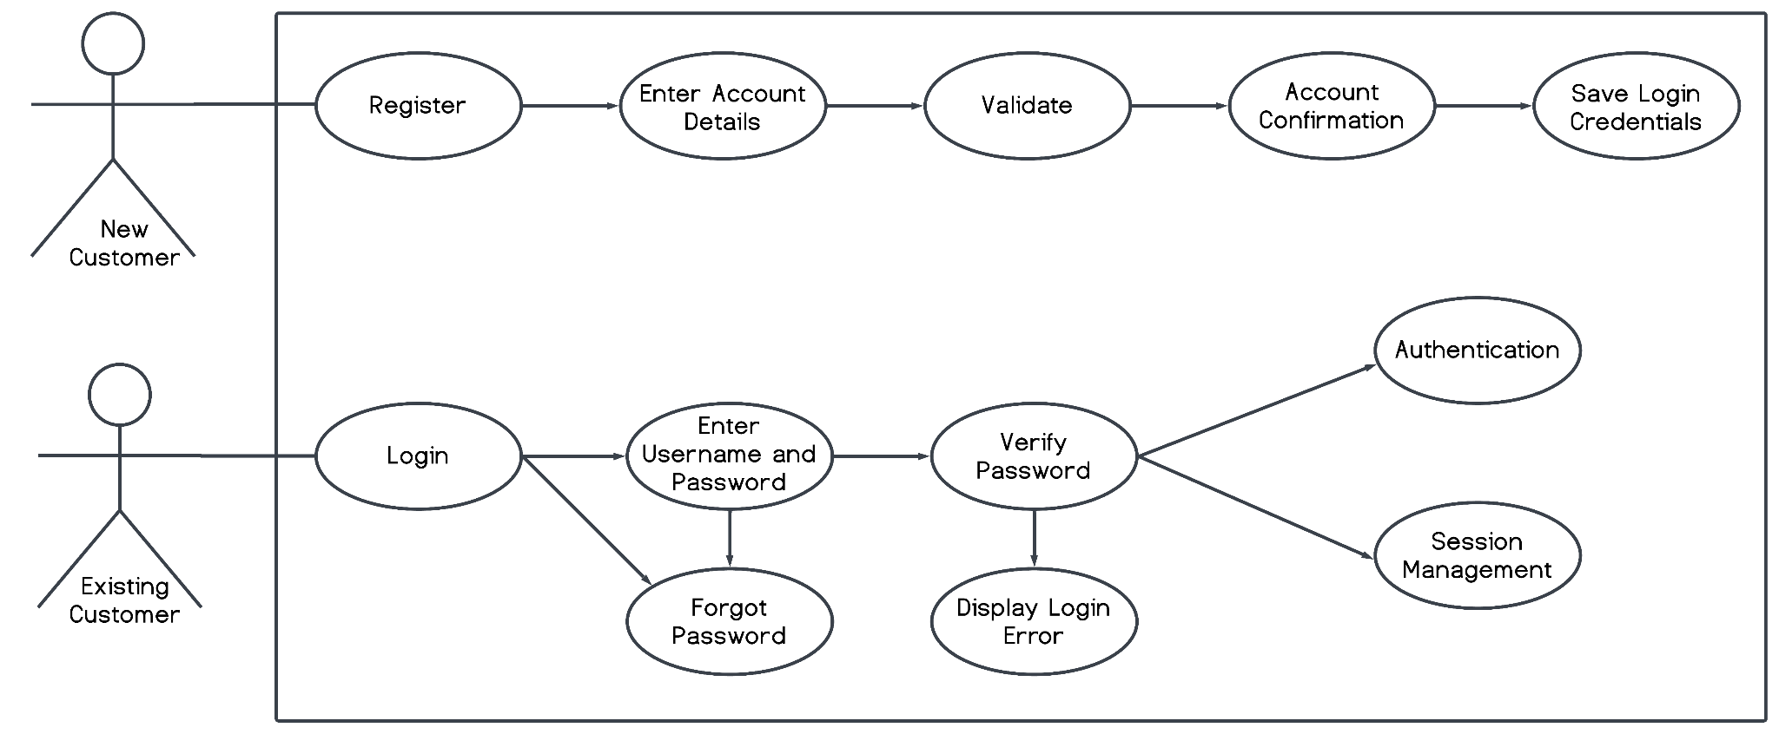

**Actors**

Existing and new customers.

**Brief Description**

Before this use case can be initiated customers must be on MoviePlug webpage. New and existing customers can log into the web-based interface of the system to browse, reserve seating, and purchase movie tickets.

**Initial Step-By-Step Description**

On the web page GUI in the upper-right corner an icon of a person shows. Upon clicking, the customer is brought to the login screen.

**New Customers:**

1. Customers without an existing account will click sign up to create a loyalty account.
2. A form will populate on the web page, prompting the customer to fill in required fields
3. Upon submitting the form, the customer’s information will be validated to check for any errors or fields not completed.
4. Customers will receive an email asking to verify email address and account creation.
5. New customer loyalty account information will be saved in the database, and converted to existing customers.
6. The system will redirect the customer back to the login page.

**Existing Customers:**

1. Customers will enter their username and password.
2. User authentication will occur to verify input, displaying error messages if not valid.
3. Three attempts will be given, on the third failed attempt account will be locked.
4. Customers can use “forgot password” if the account is locked or needs to reset password.
5. Upon valid input, the system will authenticate the user and ensure only one account session is active and return the user to the home page.

### **Customer Searching For Movie**



**Actors**

Existing or new customer

**Brief Description**

This use case describes how a customer, both new and existing, searches for a movie within the online movie ticketing system.

**Initial Step-By-Step Description**

**New Customers:**

1. The new customer opens the online movie ticketing system’s website.
2. The system presents the customer with a homepage.
3. The customer clicks on a search or browse movie option.
4. The system displays a search bar or a list of movie categories and genres.
5. The customer enters a search query into the search bar or selects a category/genre.
6. The system processes the customer’s query and presents a list of matching movie results.
7. The customer clicks on a movie from the list to view more details.
8. The system displays detailed information about the selected movie.
9. The customer can choose a showtime and proceed with booking tickets, or they can return to the list of movies and continue browsing.

**Existing Customers:**

1. The existing customer logs into their account on the online movie ticketing system.
2. The system presents the customer with their account dashboard or a personalized homepage.
3. The customer clicks on a search or browse movie option.
4. The system displays a search bar or a list of movie categories and genres.
5. The customer enters a search query into the search bar or selects a category/genre.
6. The system processes the customer’s query and presents a list of matching movie results.
7. The customer clicks on a movie from the list to view more details.
8. The system displays detailed information about the selected movie.
9. The customer can choose a showtime and proceed with booking tickets, or they can return to the list of movies and continue browsing.

### **Customer’s Payment Process**

**Actors**

New Customers, Existing Customers, Guests.

**Brief Description**

New and/or existing customers will need to access *MoviePlug* webpage so that they may be able to purchase tickets to a movie time. Using the web-based purchase process customers can purchase tickets for any available viewing. Customers should log in or proceed as a Guest. From the main page Customers can search for available showtimes and movies and proceed with the purchase process.

**Initial Step-By-Step Description**

1. Log in or continue as a Guest.

2. On the main there will be different movie titles displayed to choose from as well as an interactable search bar. If the desired movie isn’t available use the search bar to find the desired movie, if available.

3. Customer selects the desired movie tile.

4. Customer selects desired theater location.

5. Customer selects desired viewing time(s)

6. Is the theater “Deluxe Theater”?  
 *If not,* skip to **STEP 7**.  
 *If so,* select the desired seat or seats if purchasing multiple tickets.

7. Click “Proceed to Checkout”

8. Select preferred payment method (Visa, Mastercard, Apple Pay, Online banking).

9. Click Next, and input billing information if New Customer or Guest, or verify/edit existing billing information if Existing Customer.

10. Click “Proceed to Purchase”.

11. Once a transaction has been successfully processed, customers will be taken to a confirmation page where they can download/print/email their movie tickets.

12. Click the “X” from the confirmation page to exit and go back to the main page.

## **Classes / Objects**

### **<Class / Object #1>**

* + - 1. Attributes
      2. Functions

## **Non-Functional Requirements**

This section of the document overviewsMoviePlug Ticketing System’snon-functional requirements. It follows specific constraints placed on the system that impact the system’s overall performance, reliability, security, etc.

### **Performance**

MoviePlug Ticketing System’sperformance on the customer’s end depends on overall personal internet access of the user's personal equipment ie. their router/modem connectivity speeds and device hardware capabilities.

### **Reliability**

To ensure our system’s reliability and up-time, hourly database synchronization will occur and daily logs will be saved to prevent data loss. Bi-weekly updates will occur to upkeep the database to prevent any security faults.

### **Availability**

MoviePlug Ticketing System shall be accessible 24/7 to customers barring any hosting site and

database server faults.

### **Security**

MoviePlug Ticketing Systemshall utilize multiple security procedures and protocols to ensure the safety of our customers and partnered theaters:

* User logins will be capped at three password attempts, if attempts are exceeded the account is locked.
* Customer credit card information will never show the full number at purchase, only the last four digits.
* Databases shall be encrypted to protect customer’s personal information.
* Bi-weekly updates to system databases shall occur,
* Daily logs and synchronization shall occur to prevent data loss.
* IP detecting block bots are deployed to prevent bulk ticket purchases.
* Transport Layer Security (TLS) shall be utilized during purchase and login actions.

### **Maintainability**

The system’s database shall utilize a redundant array of independent disks (RAID) with minimal data redundancy to prevent data loss. Web page will be hosted by a reliable web-hosting server. Third-party plugins shall be verified for compatibility regularly. MoviePlug Ticketing Systemshall have a dedicated administrator team to upkeep web interfaces.

### **Portability**

The GUI interface of the system shall utilize Hypertext Markup Language 5 (HTML5), Cascading Style Sheets (CSS), and JavaScript to enhance web page experience that conforms to World Wide Web Consortium (W3C) standards. Ensuring accessibility on the majority of internet browsers and all customer operating systems. Our database will operate using a Microsoft SQL Server as our relational database to store records, accounts, and titles.

# **System Description**

The purpose of MoviePlug Ticketing Systemis to ease customers' movie ticket purchasing experience. By providing a convenient online web-based platform that essentially acts as a hub for customers purchasing movie tickets. It has access to 20 partnered theaters across the San Diego region offering access to both regular and deluxe theater seating reservations. The system shall interface with several APIs and a relational database that streamlines processes such as movie searches, ticket purchases, seat reservations, payment, and reviews. Customer accounts are available and loyal customers reap rewards through their loyalty points saved to their account, with their commitment to our product. Overall, the system will provide a user-friendly portal for movie-goers that offers the ability to skip long lines on movie night.

# **Software Architecture Overview**

# **Architectural Diagram**

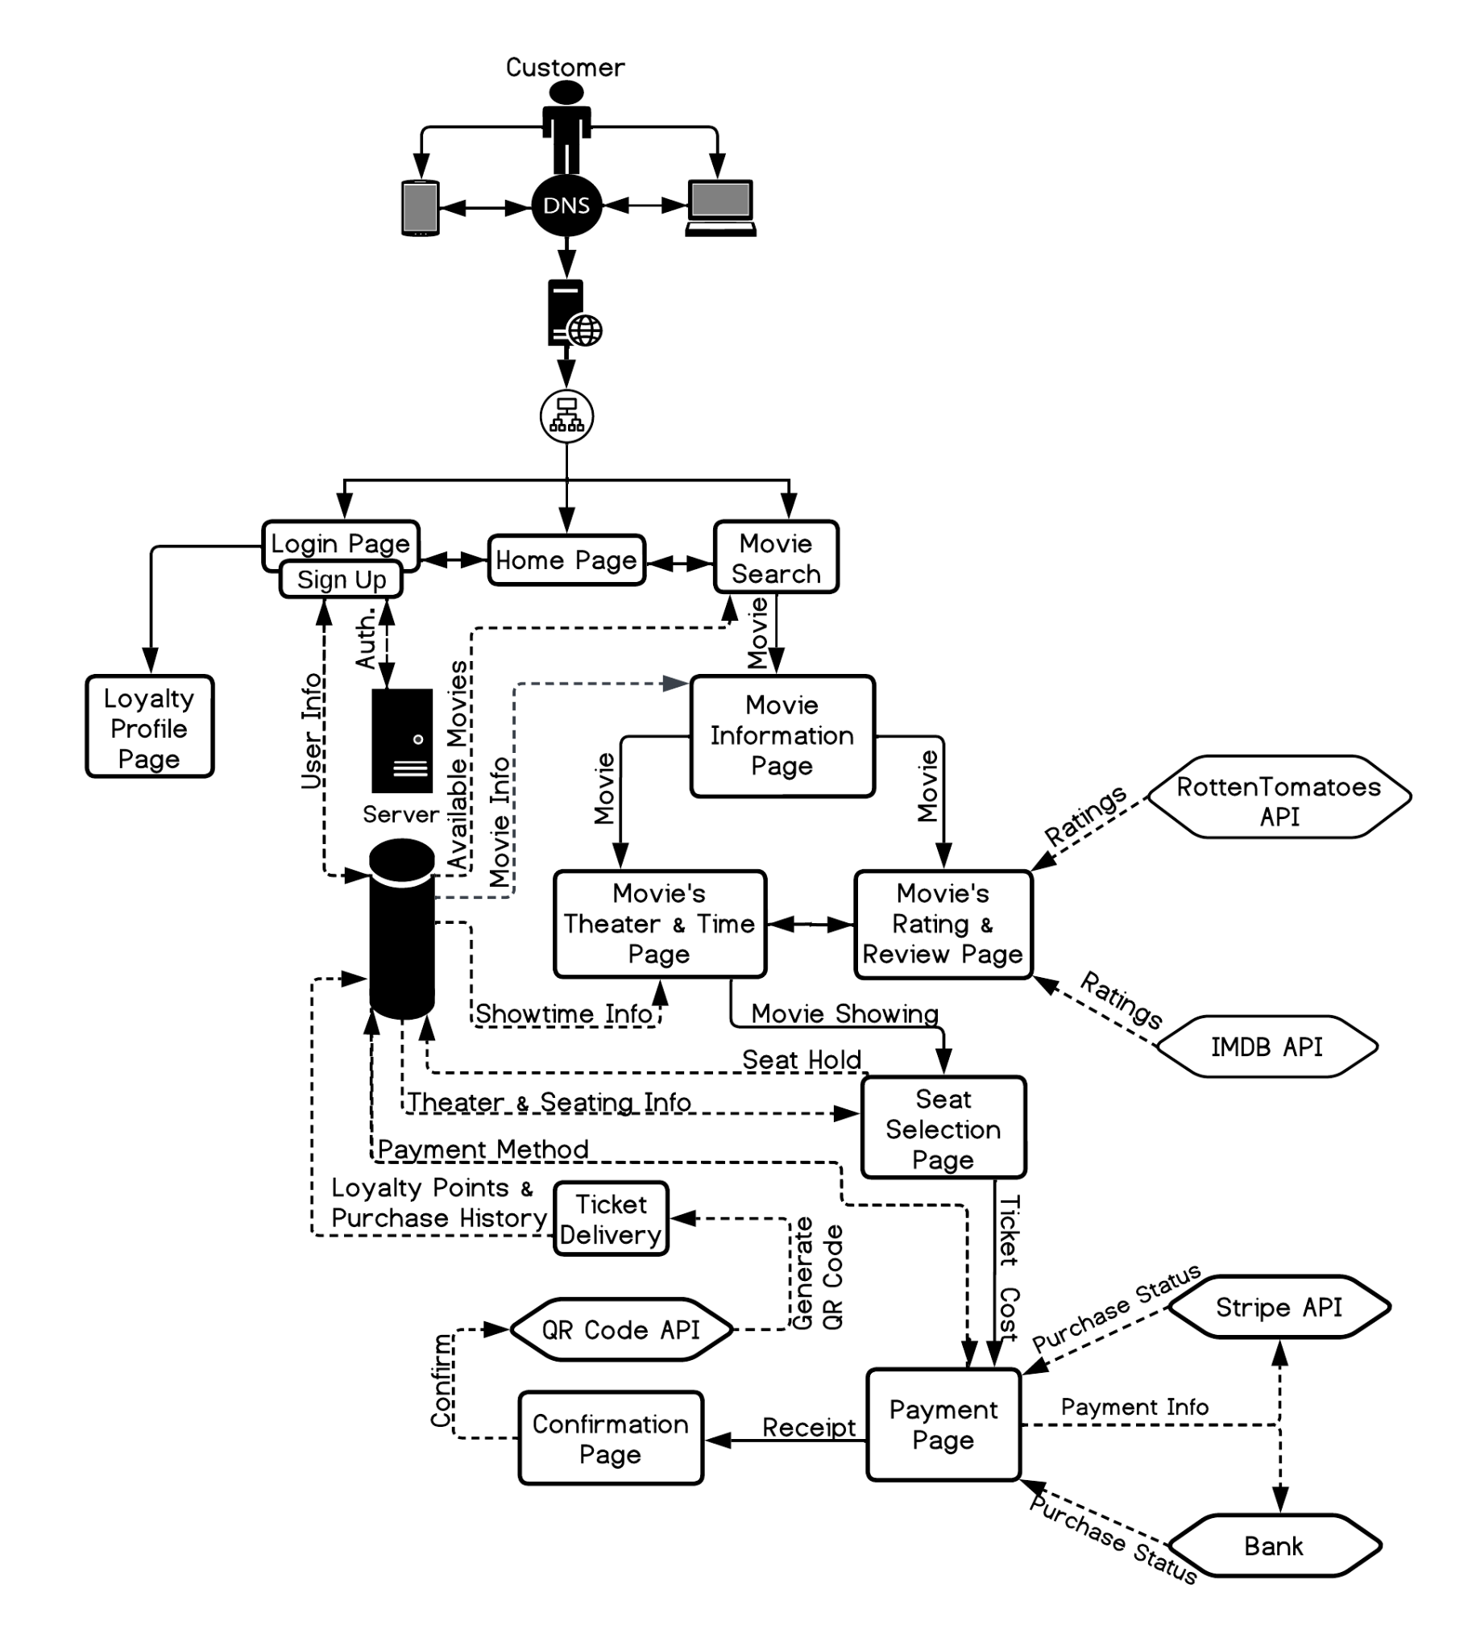

## SWA Description

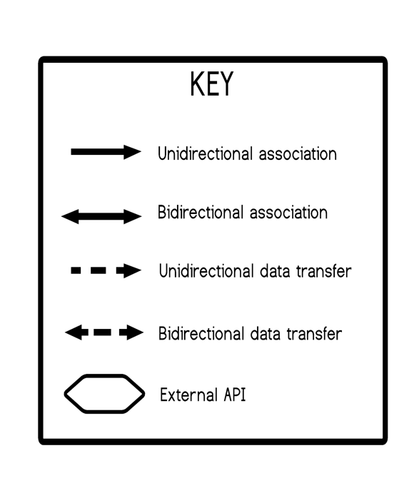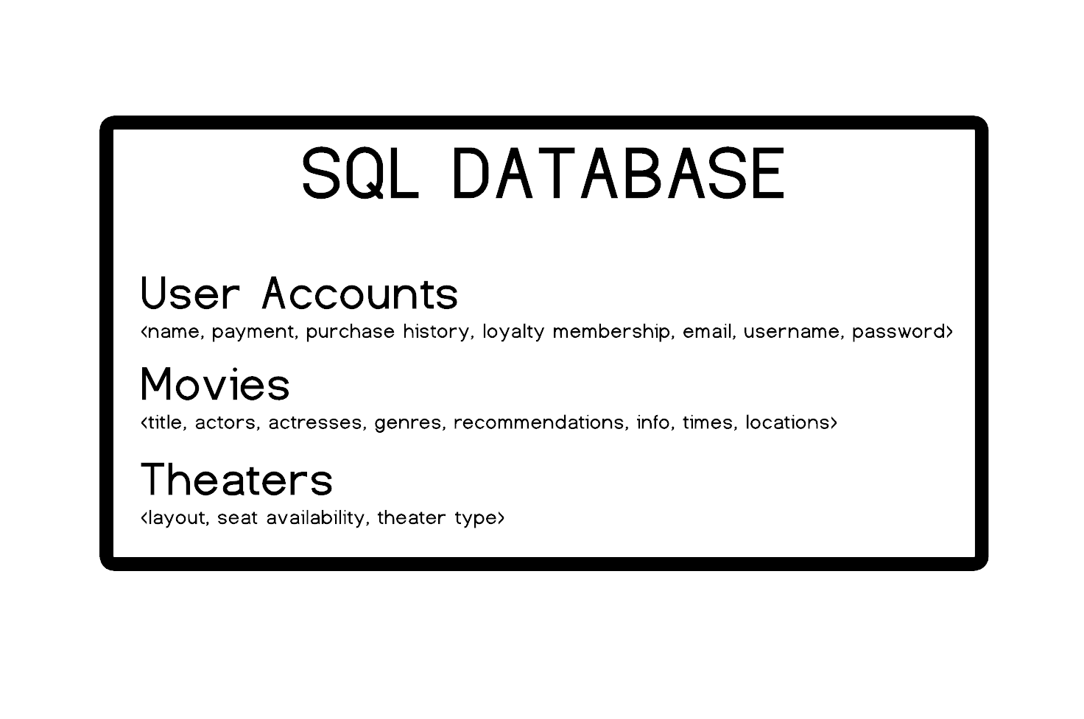

## The following describe the architecture and functionality of the UI interface for customers.

## 

## 

## 

## 

## 

## 

## 

## 

## UML Class Diagram

## 

## Description of Classes

● *User() - Contains user information and validates information with DB.*

● *Booking() - Contains booking information like booking id, the user who is booking and screenings.*

● *Payment() - Contains user input such as card information and uses 3rd party API to process payment, and transaction information.*

● *Ticket() - Contains all ticket details such as user name, booking confirmation, and assigned seat if applicable.*

● *Seat() - Contains the user designated seat provided that the theater in question is an assigned seating theater.*

● *Theater() - Contains theater branch information such as name, theater id and capacity among other things.*

● *Screening() - Contains information in regards to actual screening date, time, theater location, film name.*

● *Movie() - Contains actual movie information such as title, genre, date released, and movie identifier (internal purposes).*

## Description of Attributes

● User()

○ user_id - string - user display name

○ username - string user login

○ password - string user password

○ email - string email address

● Booking()

○ booking_id - string - booking confirmation

○ user - - strings - information coming from the User() class containing user info

○ screening - multiple data types coming from the Screening() class

● Payment()

○ payment_id - string - payment confirmation id returned from 3rd party API

○ amount - int - total amount being charged for ticket(s)

○ payment_date - int - date transaction was made in xx/xx/xxxx xx:xx:xx format

● Ticket()

○ ticket_id - int - ticket id unique to theater, movie, and user

○ booking - multiple data types coming from the booking class

○ seat - string - passed from the Seat() class

● Seat()

○ seat_id - string - composed from the theater information as well as seat number

○ theater - string/int - information passed from the Theater() class

○ seat_number - int - seat number within a given row

○ is_occupied - bool - flag that determines if seat is already taken

● Movie()

○ movie_id - int - unique ID that corresponds to movie within theater (internal use)

○ title - string - movie title

○ genre - string - movie genre

○ release_date - int - contains date of when the movie will be released in theaters in xx/xx/xxxx format

● Screening()

○ screening_id - unique ID that is composed of movie information such as location, movie title, movie times (internal use)

○ movie - string - information brought over from the Movie() class contains movie

○ theater - object - contains theater information

○ date_time - int - Date and time of the screening

● Theater()

○ theater_id - int - Unique identifier for the theater (internal use)

○ name - string - Name of the theater

○ capacity - int - Maximum seating capacity of the theater

## 

## 

## Description of Operations

● User()

○ Register() - Registers user from user input information

○ Login() - Using user input information validates credentials with DB information

● Booking()

○ Add_Ticket() - Adds ticket to the purchase, marks seat as unavailable (if applicable), updates theater capacity, and will queue for printing at a later step.

● Payment()

○ Process_Payment() - 3rd party API that processes payment

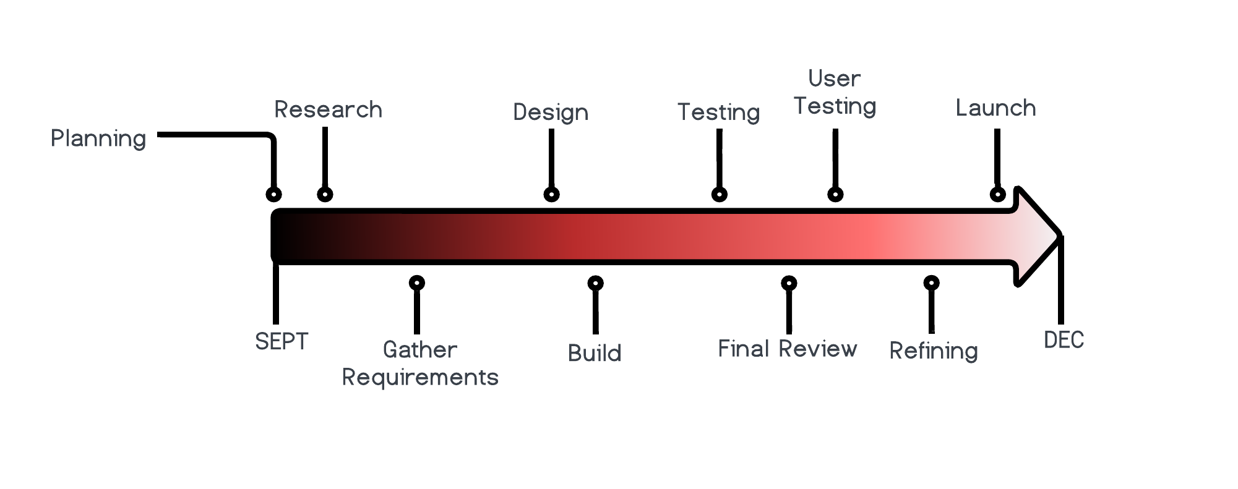

# **Development Plan and Timeline**

## 

## Partitioning of Tasks

To ensure the four month timeline is met these have been assigned to the following teams:

1. **Planning:**

a. **Project Manager** - POC: Justine Rosario Rubenero

2. **Research**:

a. **UX/UI Team** - POC: Shanique Doodlebob

3. **Gather Requirements:**

a. **Project Manager** - POC: Justine Rosario Rubenero

b. **UX/UI Team** - POC: Shanique Doodlebob

4. **Design:**

a. **UX/UI Team** - POC: Shanique Doodlebob

5. **Build:**

a. **Front-End Development Team** - POC: Terrance Clifford III

b. **Back-End Development Team** - POC: Chris P. Baycoon

6. **Testing:**

a. **Front-End Development Team** - POC: Terrance Clifford III

b. **Back-End Development Team** - POC: Chris P. Baycoon

c. **QA Team** - POC: Naomi Yerba

d. **Tester Team** - POC: Wallace Steffingshire

7. **Final Review:**

a. **Project Manager** - POC: Justine Rosario Rubenero

b. **Software Architect** - POC: Davy Jones

c. **QA Team** - POC: Naomi Yerba

8. **User Testing:**

a. **UX/UI Team** - POC: Shanique Doodlebob

b. **QA Team** - POC: Naomi Yerba

c. **Tester Team** - POC: Wallace Steffingshire

9. **Refining:**

a. **Software Architect** - POC: Davy Jones

b. **Front-End Development Team** - POC: Terrance Clifford III

c. **Back-End Development Team** - POC: Chris P. Baycoon

10. **Launch:**

a. **Project Manager** - POC: Justine Rosario Rubenero

b. **Software Architect** - POC: Davy Jones

## Team Member Responsibilities

● **Project Manager**: Justine Rosario Rubenero

○ Develop a project plan and lead product planning meetings with teams.

○ Develop functional specifications.

○ Plan, estimate, and manage resources and the project budget.

○ Conduct initial interviews with stakeholders.

○ Evaluate and ensure timeline processes.

○ Launch and release.

● **UX/UI Team |*****UX/UI Lead***: Shanique Doodlebob

○ Conduct user interviews.

○ Design website wireframe.

○ Research competition.

○ Gather Requirements

● **Front-End Development Team | *FE Lead*:** Terrance Clifford III

○ Build the features laid out in the Sprint.

○ Update the status of the software project to the Project Manager and Lead.

● **Back-End Development Team** | ***BE Lead:*** Chris P. Baycoon

○ Integrate web services and APIs.

○ Build servers, frameworks, databases.

○ Integrate with front-end capabilities.

● **QA Team | *QA Lead:*** Naomi Yerba

○ Evaluate execution of processes and/or production.

○ Identify and document deviations in SOPs.

○ Provide feedback about the results of the quality assurance.

● **Tester Team | *Test Lead:*** Wallace Steffingshire

○ Understand requirements, and constraints to create and run test cases.

○ Build and run test cases to detect bugs and report them.

● **Software Architect:** Davy Jones

○ Define the technical and functional architecture of the overall system.

○ Guide developers in the design and implementation of the solution.

○ Ensure functionality of the final product.